**Rzz666** Final Project INFO 5100

A Comprehensive view and work-area of Export business

This project provides an integrated solution for the export company, including check the suppliers and related product quantity, place orders according to customers' orders, and select proper flight to transport product.

What's more, an export employee can see the most valuable product should be sold in each country based on calculating the detailed profit. All the costs contain product original price and sale price, and transportation fee would be taken into consideration. Facing the fierce competition in the mutable international trade market, this empowers businessman to make a wiser decision and handle the business matters with high proficiency.

There are four roles being involved: supplier, [export](javascript:;) [company](javascript:;), airline, and Country.

**Suppliers** can provide with kinds of products and the interface which enables customers to select and order items; **Export** [**company**](javascript:;) has its warehouse to store the products bought from suppliers and the departments to sell the products abroad and analyze revenues, as well as decide to where they will sell products. **Airlines** have their own airplanes to transport goods and can set the schedules. **Countries** can show their products’ market price and add customers.

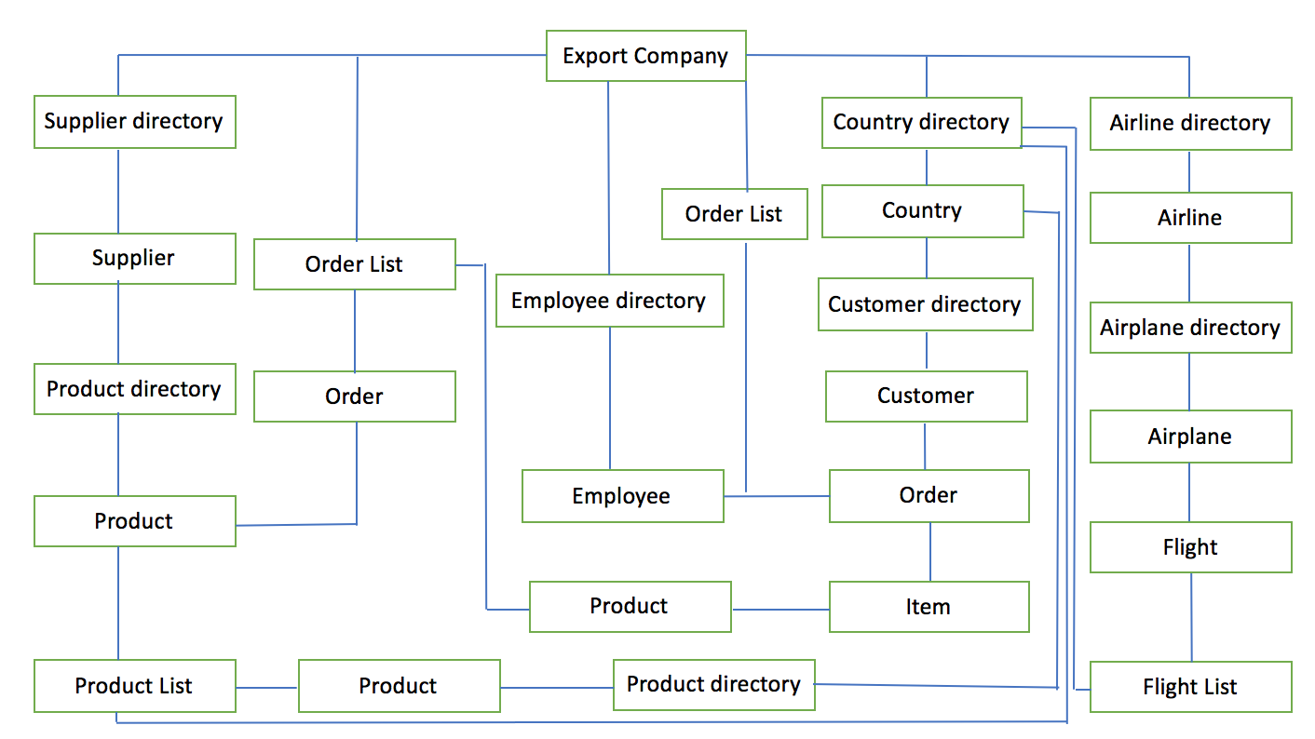

Export company can make an order from Suppliers. It also has information about the product standard market price for each country and flight schedule to decide whether to sell this product in each region. Customer can make orders from the company’s employee. Airliner includes many kinds of airplanes that will assign flight and have its own departure, destination, and transportation cost.

Based on product price from suppliers and shipping cost from airliners, export company departments will calculate revenue for each order from customers and get the total revenue of the year.